STAR CLASSES

APTECH

Computer Education

Gulistan-e-Johar, Karachi.

CPISM E-Project
1st Semester

Project Mentor
Miss. Fatima Bukhari

Developed and designed by:
Areesha Shahid, Daniyal Ahmed, Hussain Zia

This is to certify that:

STD: AREESHA
STD: DANIYAL
STD: HUSSAIN

Has successfully designed and developed the
E-PROJECT “STAR CLASSES”
Starting Date:
20-SEPTEMBER-2024

Submit Date:
20-OCTOBER-2024

ACKNOWLEDGMENT

We are thankful to almighty, ALLAH for his grace and mercy for giving us the strength and ability to make us complete this e-Project website. We hereby present the project on ‘STAR CLASSES ACADEMY’ in your hands. We have tried our best to take all relevant and important topics into consideration so that this project may become more effective& a better outlook to come. This project has been developed with the help of HTML, CSS, JavaScript, BOOTSTRAP, and Responsiveness.
We earnestly hope that this project will provide all the necessary information required for the user to fulfill their requirement. However, suggestions for improvement of the project will be thankfully acknowledged.

THANK YOU

PREFACE

First of all, we would like to thank ALLAH the almighty, who gave us the mind to think and the heart to feel creativity and creation depends on thinking.

Many people contributed to this project, and I would like to thank all of them. Very special thanks to our teacher Miss Fatima of APTECH for her expert advice and brilliant suggestion and for always encouraging us to do our best. Indeed, class fellows are very important and we would like to thank all of them for their kind appreciation, encouragement, and moral support.

We would also like to express our deepest gratitude to our parents whose well wishes enabled us to transform our dream into a reality. Finally our sincere thanks to our teacher Miss Fatima for all their assistance in making this concept a reality.
PROJECT BRIEF

PROBLEM STATEMENT:
Introduction:
Introduction to Star Classes:
At Star Classes, we offer a comprehensive curriculum that blends Physics, Chemistry, and Graphic Designing. Our Physics program delves into the fundamental laws of nature, encouraging critical thinking and problem-solving. In Chemistry, students explore the building blocks of matter, fostering curiosity about chemical reactions and their real-world applications. Our Graphic Designing course combines creativity with technical skills, teaching students to communicate ideas visually. Each subject is taught by experienced instructors, ensuring a robust understanding and practical experience. With a focus on interdisciplinary learning, we empower students to connect concepts across these diverse fields. Join us to ignite your passion for science and creativity!
SOLUTION:
The solution for the problem, mentioned in the “Introduction to Star Classes”:
At Star Classes, we provide an engaging and holistic approach to learning Physics, Chemistry, and Graphic Designing, tailored for curious minds. In our Physics program, students explore the fundamental principles governing the universe, enhancing their analytical skills through hands-on experiments and real-world applications. The Chemistry curriculum invites learners to investigate the properties and reactions of matter, promoting an understanding of its impact on everyday life, from medicine to environmental science.
Our Graphic Designing course nurtures creativity by teaching essential design principles and software skills, empowering students to express their ideas visually. Each subject is led by passionate instructors who foster a supportive learning environment, encouraging collaboration and innovation. We emphasize interdisciplinary connections, helping students see the relationships between science and design. Join us at Star Classes to embark on an exciting journey that fuels your passion for knowledge and creativity!
CUSTOMER REQUIREMENTS & SPECIFICATION

PROJECT SCOPE & REQUIREMENTS:
The Web site is to be created based on the following requirements.

Here is a flowchart structure based on the provided overview:

Level 1: Home

Logo (Top)
Menu
- Introduction
- Courses
- Faculty
- Success Stories
- Contact
- Other

Level 2: Menu Options

Introduction
- Brief Overview
Courses
Subject Filters
- Commerce
- Mathematics
- Languages
Course Stream Selection
- List of subjects specific to selected stream
Course Details
- Information
- Download PDF
Faculty
- Teacher Details
Success Stories
- Past Achievements
Contact
- Address
- Email
- Phone
- Google Maps

Level 3: Course Information

Subject Filters
- Commerce
- Mathematics
- Languages
Course Stream Selection
- List of subjects
Course Details
- Information
- Download PDF

Level 4: Faculty and Success Stories

Faculty
- Teacher Details
Success Stories
- Past Achievements

Level 5: Contact and Additional Functionalities

Contact
- Address
- Email
- Phone
- Google Maps
Scrolling Ticker
- Date
- Time
- Location
Visitor Counter

Technical Requirements

- Responsive Design
- Smooth Animations (CSS)
- Downloadable Content (PDF)

This flowchart outlines the main components and functionalities of the portal, providing a clear structure for development.

STANDARDS PLAN:

- Every code block must have comments.

- The logic of the program needs to be explained. Proper documentation should be maintained.
- Complete Project Report along with synopsis, code, and documentation should be prepared.

HARDWARE REQUIREMENTS:

- A minimum computer system that will help you access all the tools in the courses is a Pentium 166 or better

- 64 Megabytes of RAM or better

SOFTWARE REQUIREMENTS:

Notepad/ HTML Editor
Visual Studio
Sublime
PROJECT PLAN:

CORE STRENGTH:

    - Our site has a professional look & is user-friendly so that a user can access any page of our website easily.

    - We have a unique drop-down MENU that contains links to the cards on our website.

    - We have a special type of Contact Us Page which contains not only the contact information but a comment box, which, the user can contact directly. Due to this customer can contact us easily.

    - We have developed the whole website on <Div>s. Tables are used only for tabular forms of data that had to be entered into our website.

    - Our website is cross-browser compatible. We have tested our website on all A-Grade Browsers.

    - Us, we have entered information in bulks for giving the user the maximum amount of information and knowledge about the specific cards.

    - We have made it as simple as possible so that a user doesn’t have to deal with any complications and browse any page he/she likes easily.

DELIVERABLES:
- Working Websites with Source Code
- Status Report 1
- Status Report 2
- Final Documentation

PROJECT DEPENDENCE:
- Not completely compatible on Internet Explorer 6.

TESTING & QUALITY PLAN:
- Do All Pages Open?

- Are all hyperlinks working?

- Are the web page contents devoid of spelling mistakes?

- Are all the web components working?

- Is websites working properly on Google Chrome?

APPENDIX
TASK SHEET:
Project Title | Star Classes | Activity Plan prepared by | Areesha Shahid
S. # | Task | Actual Start Date |  | Status
01. | Problem Review | 21 Sept 2024 | Daniyal | Done
02. | Layout of Website | 25 Sept 2024 | Areesha | Done
03. | Article Data Searching | 01 Oct 2024 | Hussain | Done
04. | Collection of Images | 04 Oct 2024 | Areesha | Done
05. | Inner Pages | 08 Oct 2024 | Hussain | Done
06. | Checking Links | 09 Oct 2024 | Areesha | Done
07. | Data Searching | 12 Oct 2024 | Hussain and Daniyal | Done
08. | Checking of cross Browsers compatibility | 15 Oct 2024 | Areesha | Done
09. | Documentation | 18 Oct 2024 | Hussain and Areesha | Done

SNAPSHOTS

HOME PAGE
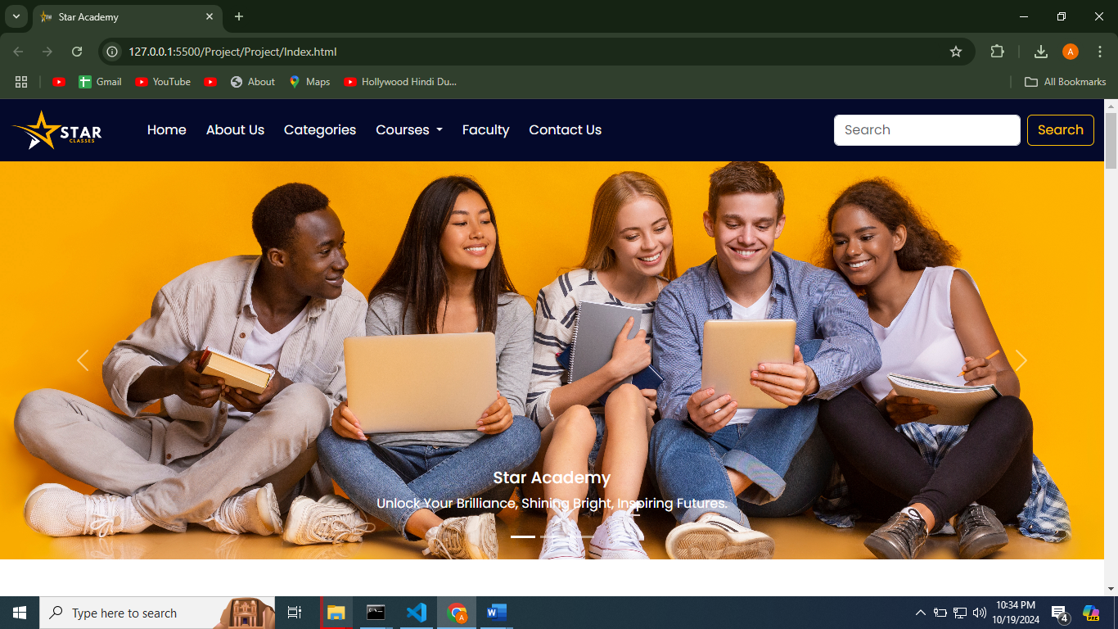
ABOUT US SECTION
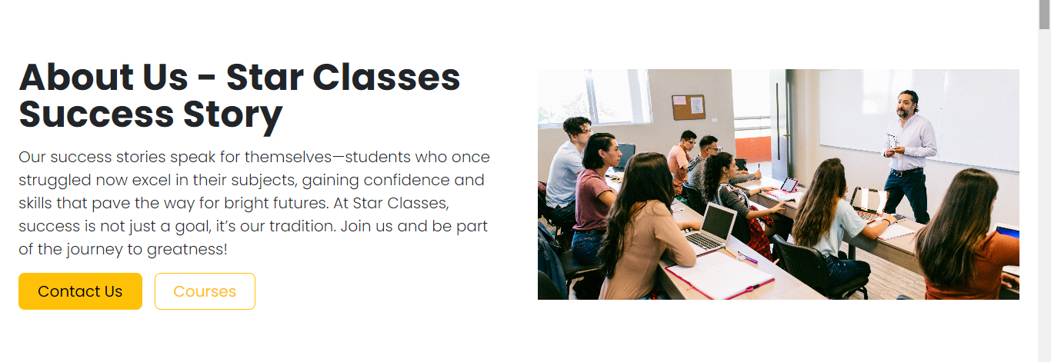

CATEGORIES SECTION
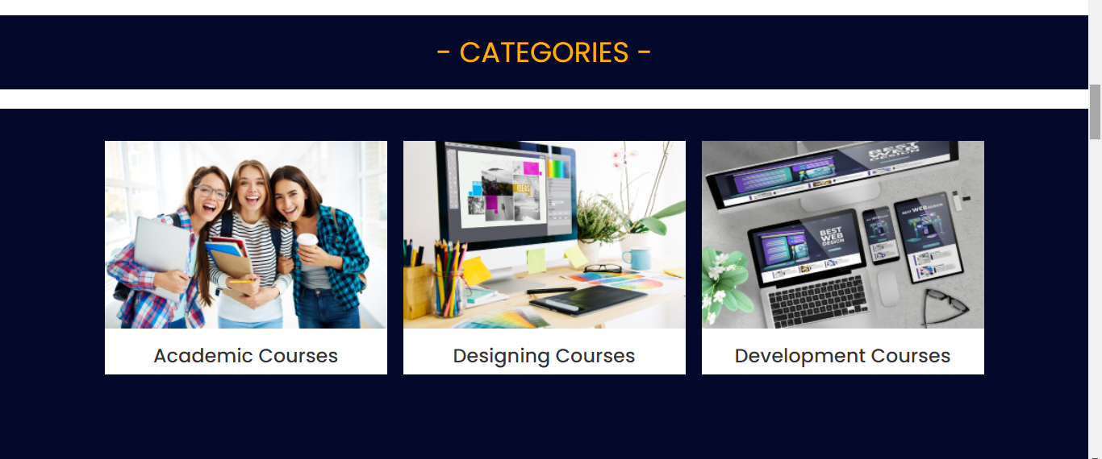
COURSES SECTION
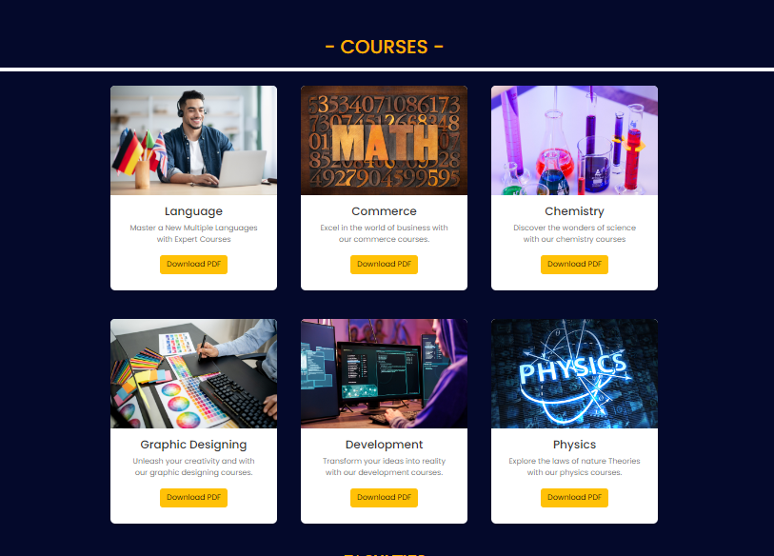
FACULTY SECTION
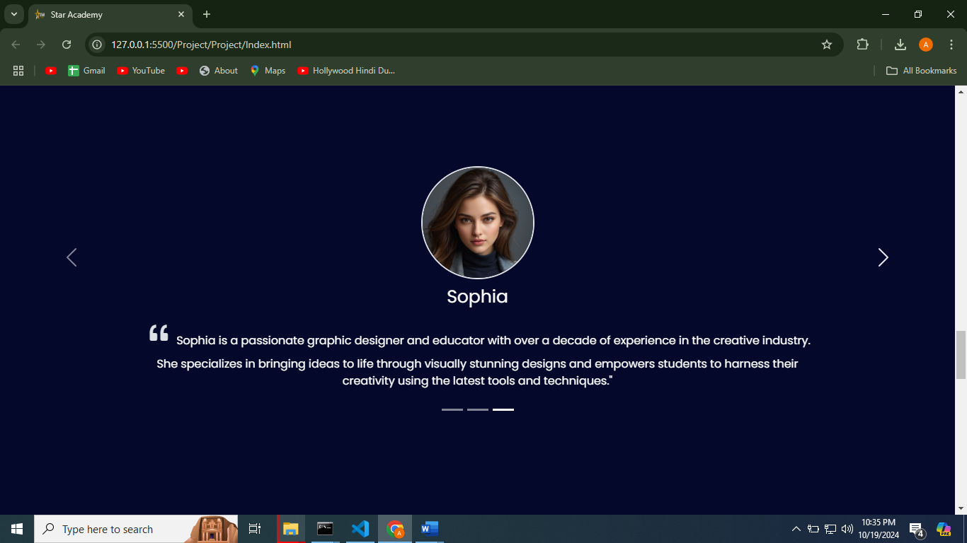
CONTACT US SECTION
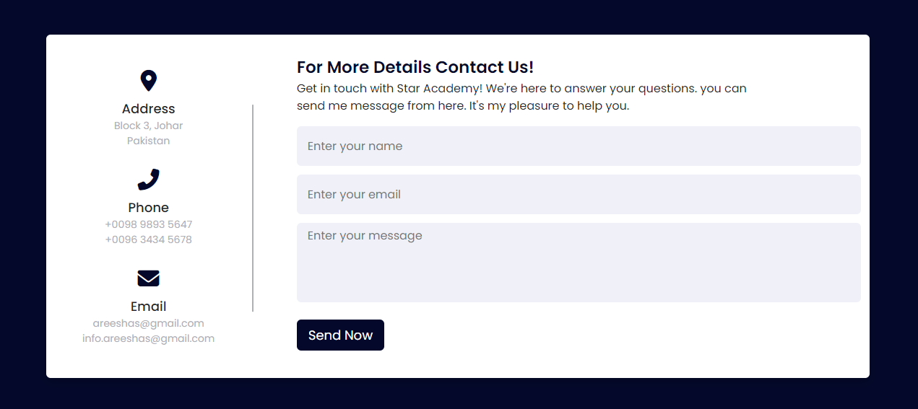
MAP SECTION
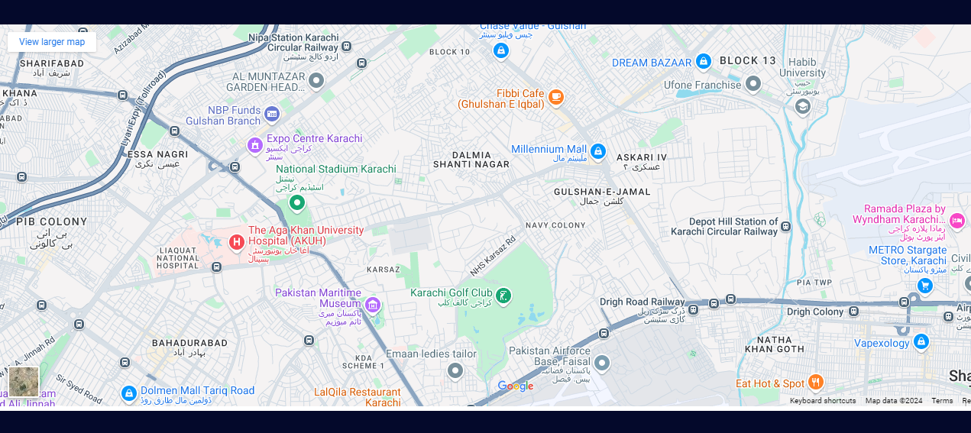

FOOTER SECTION
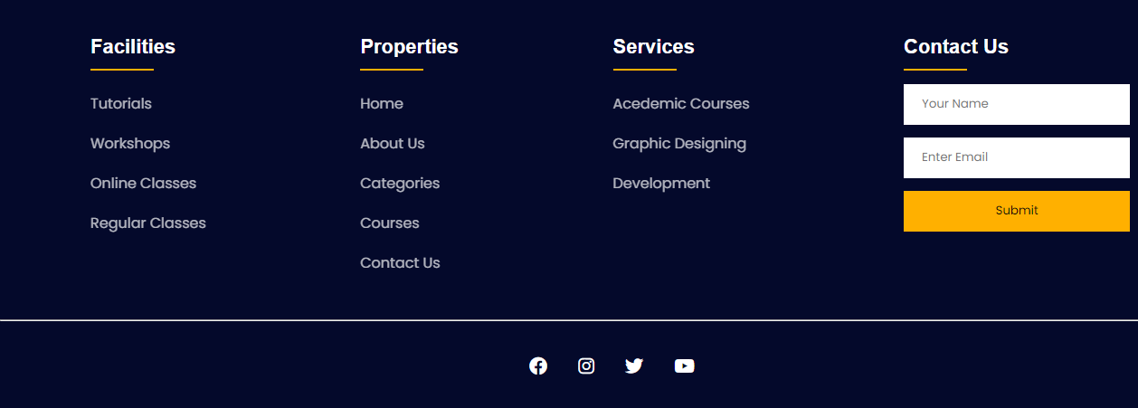

HOME/INDEX PAGE CODING:
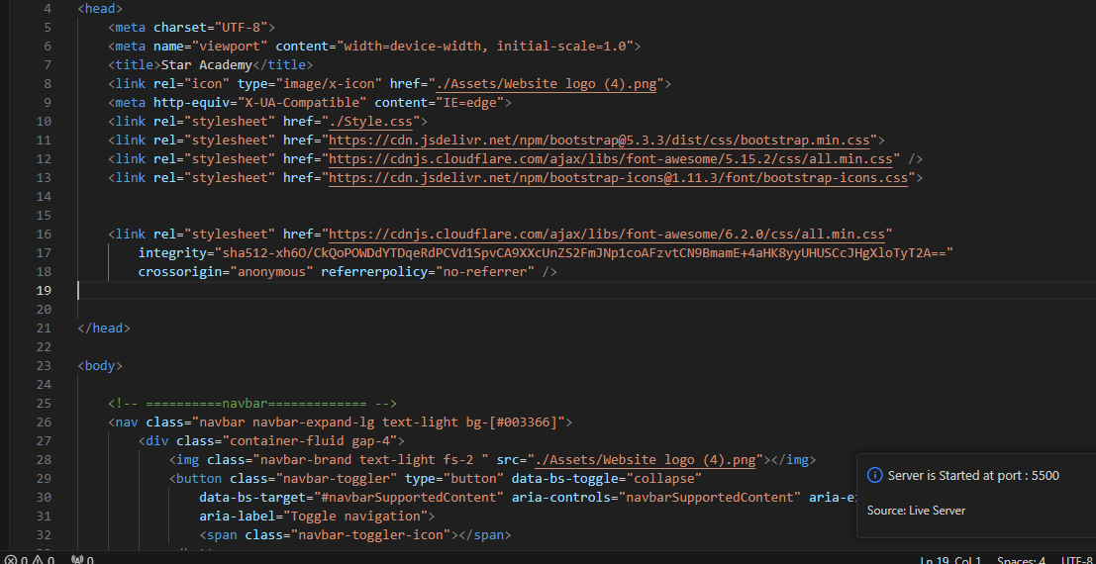
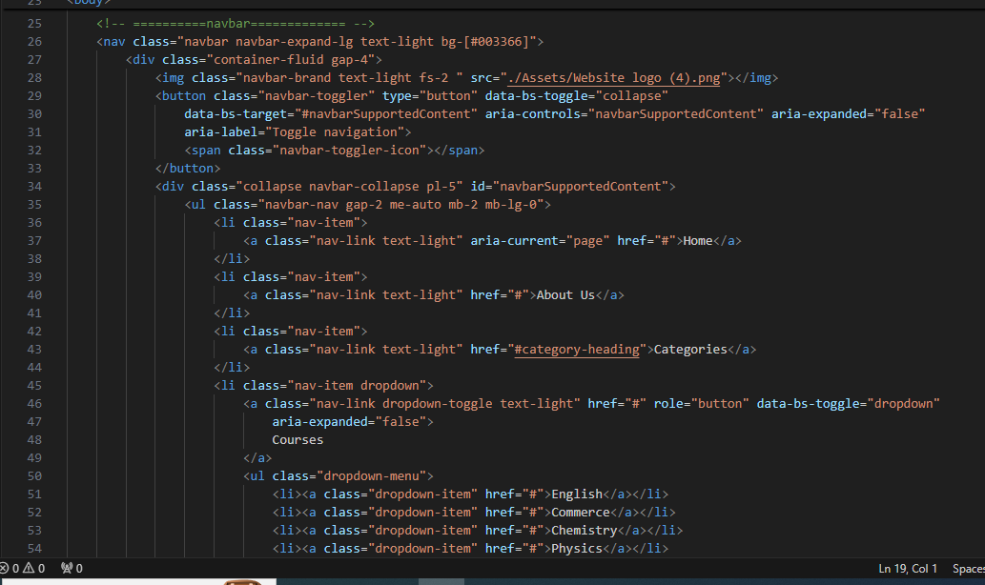
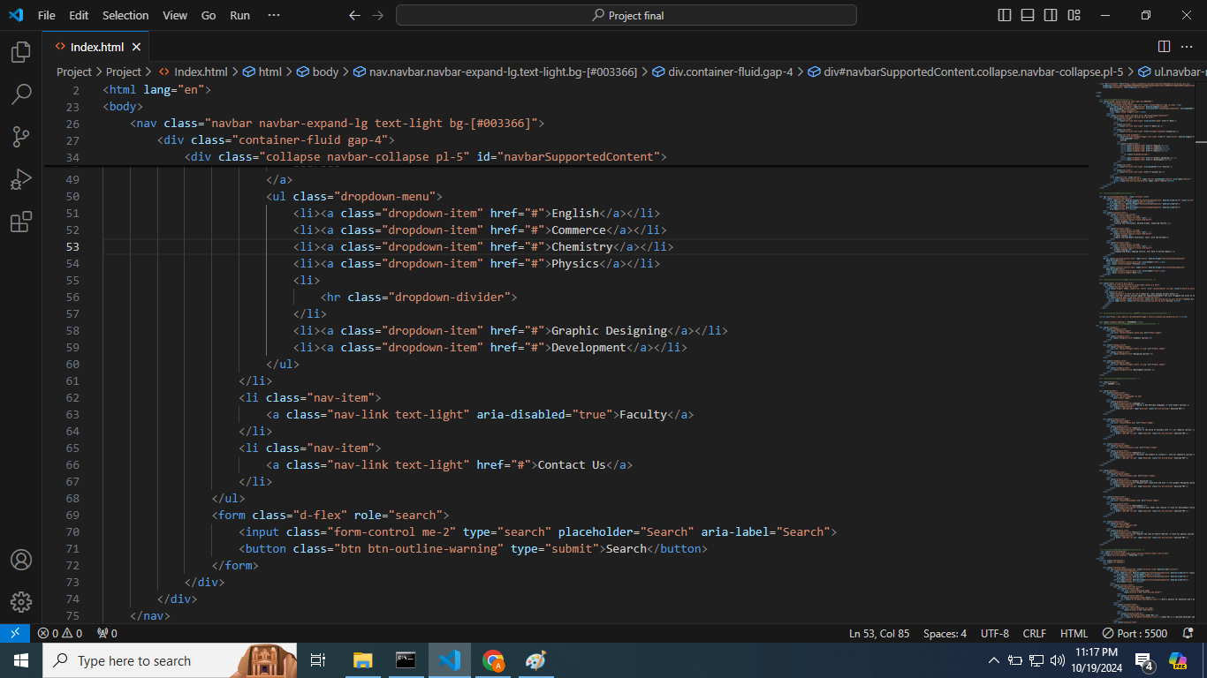
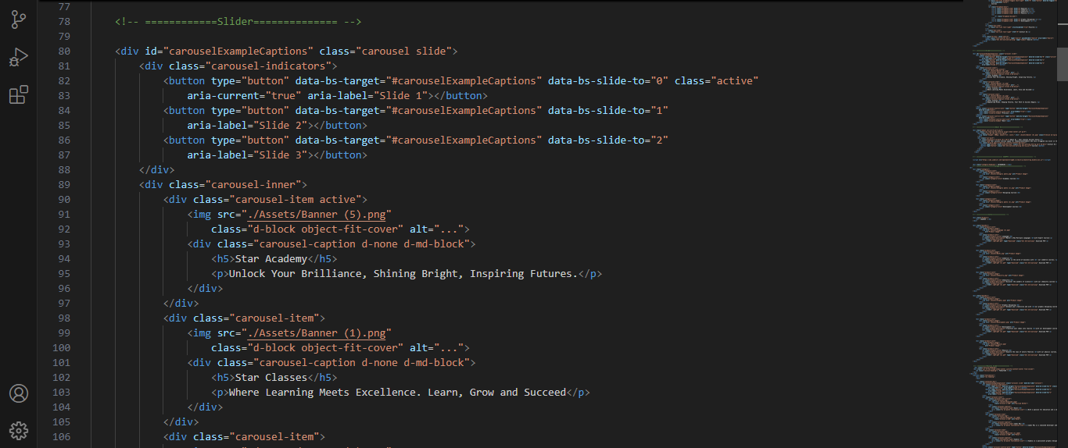

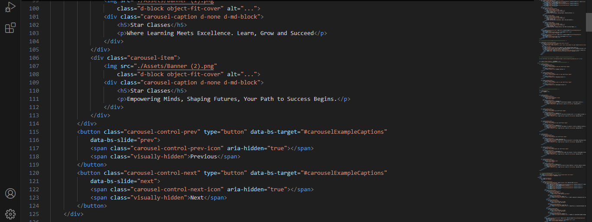
ABOUT US/INDEX PAGE CODING:
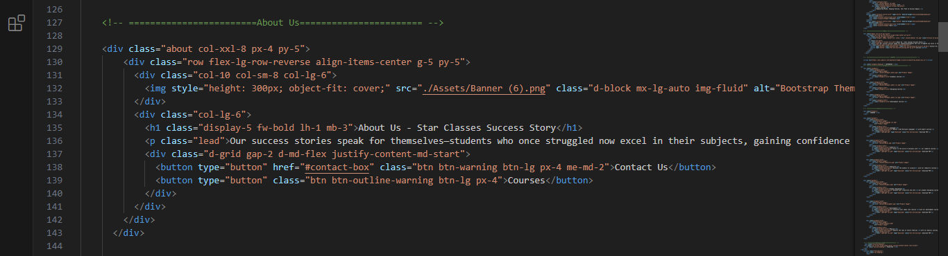
CATEGORIES/INDEX PAGE CODING:
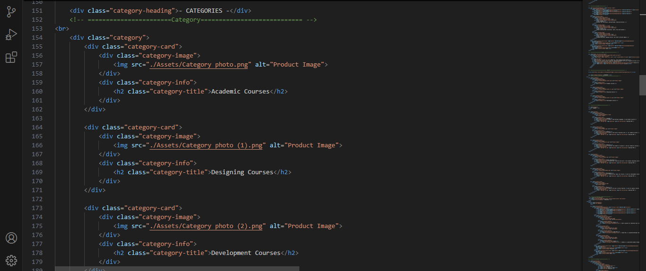
COURSES/INDEX PAGE CODING:
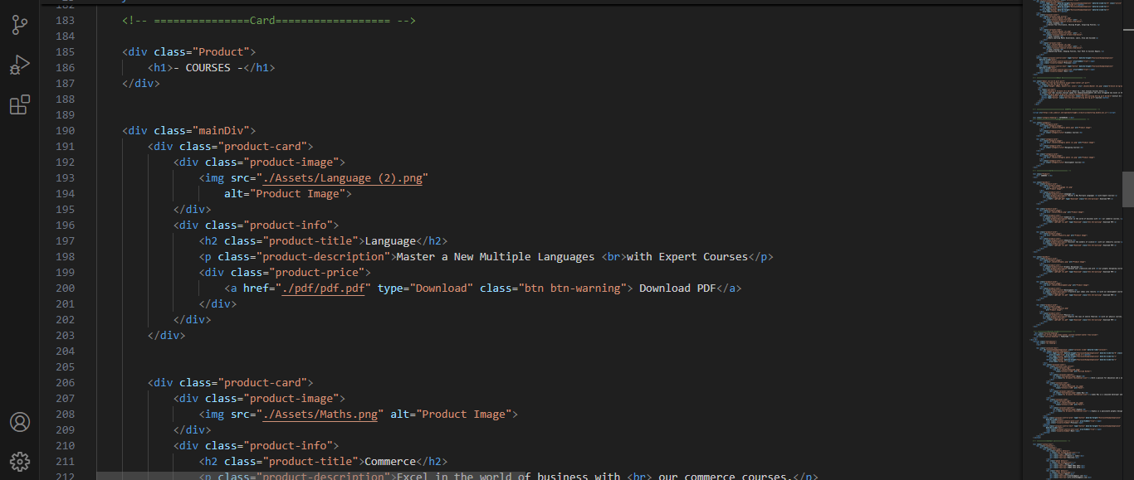
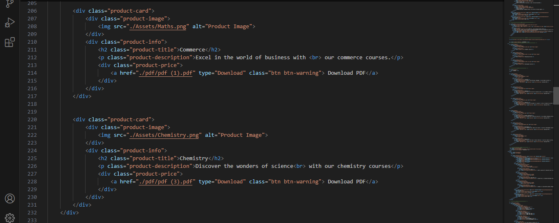

FACULTY/INDEX PAGE CODING:
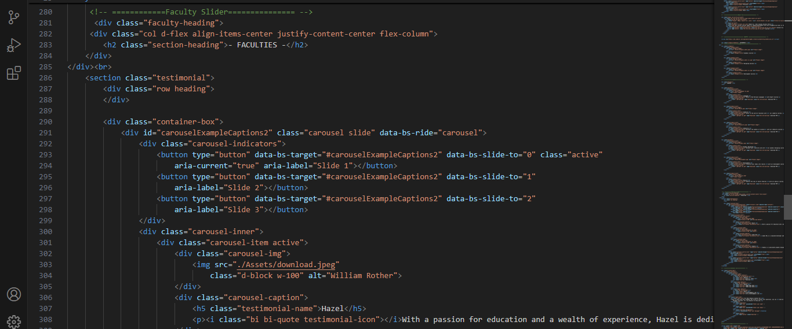
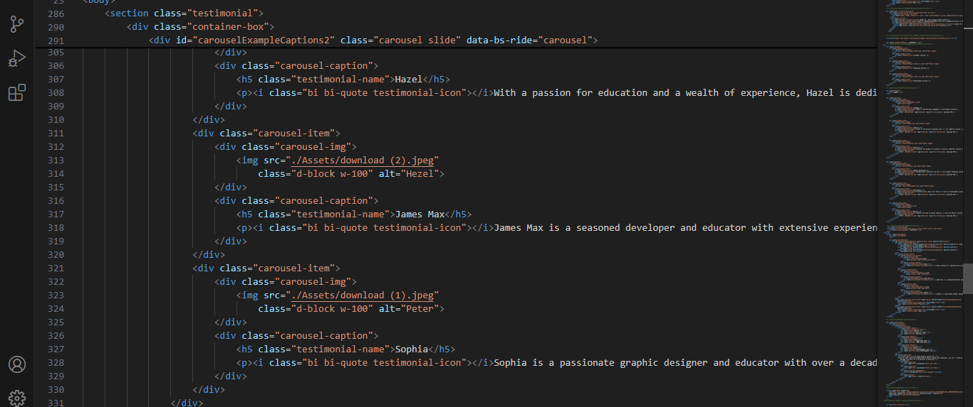
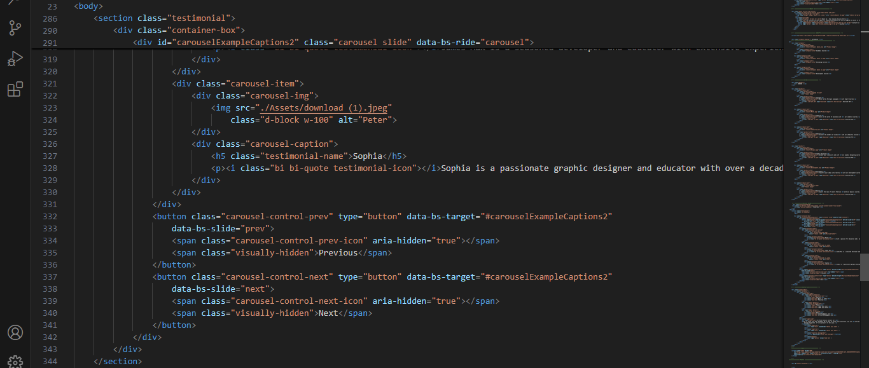
CONTACT US/INDEX PAGE CODING:
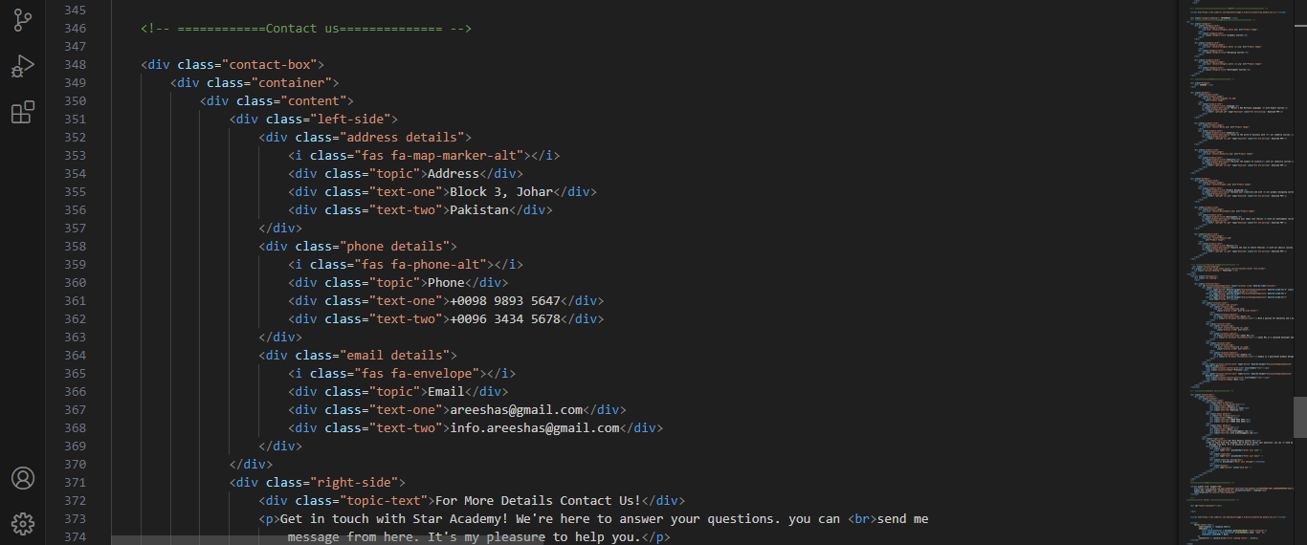
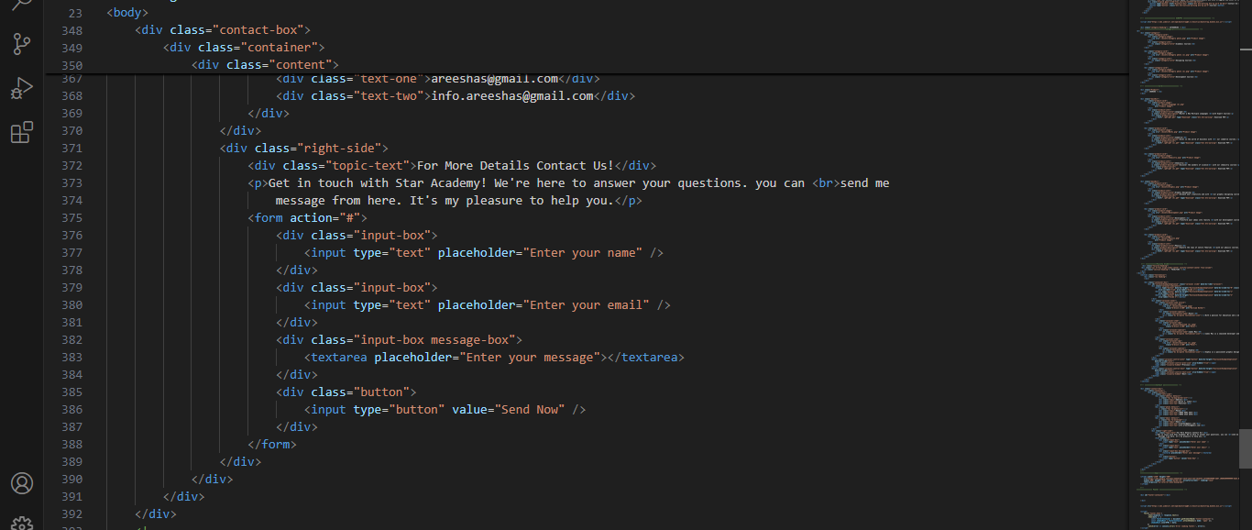
MAP/INDEX PAGE CODING:
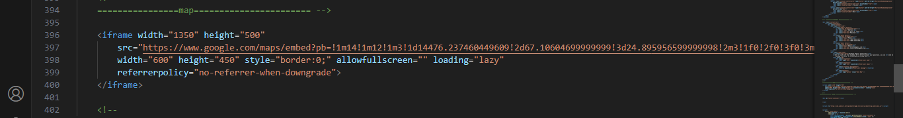
FOOTER/INDEX PAGE CODING:
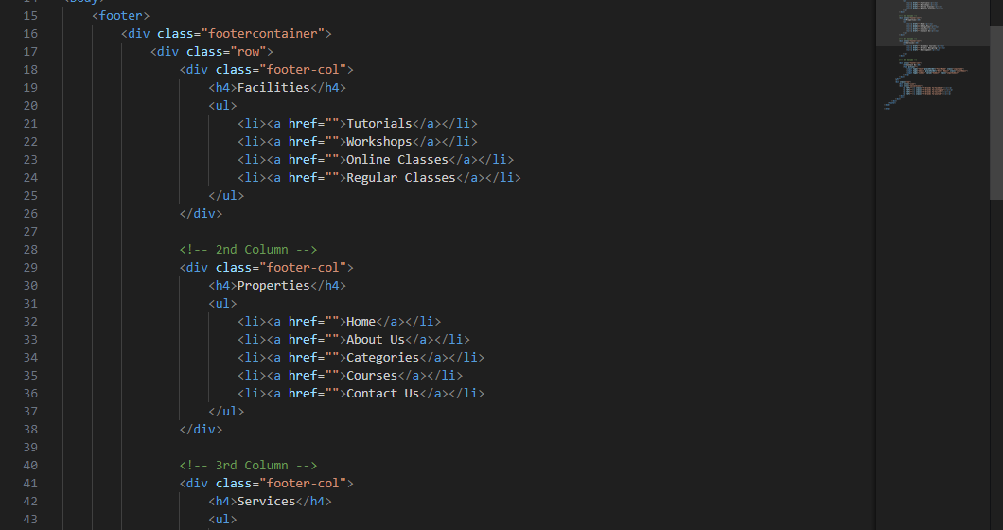
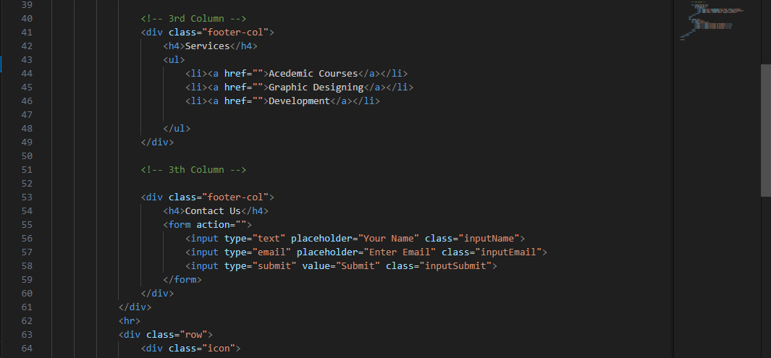
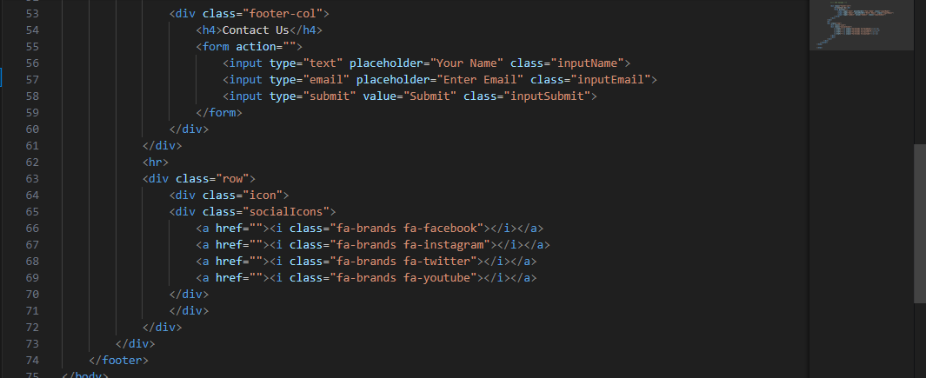
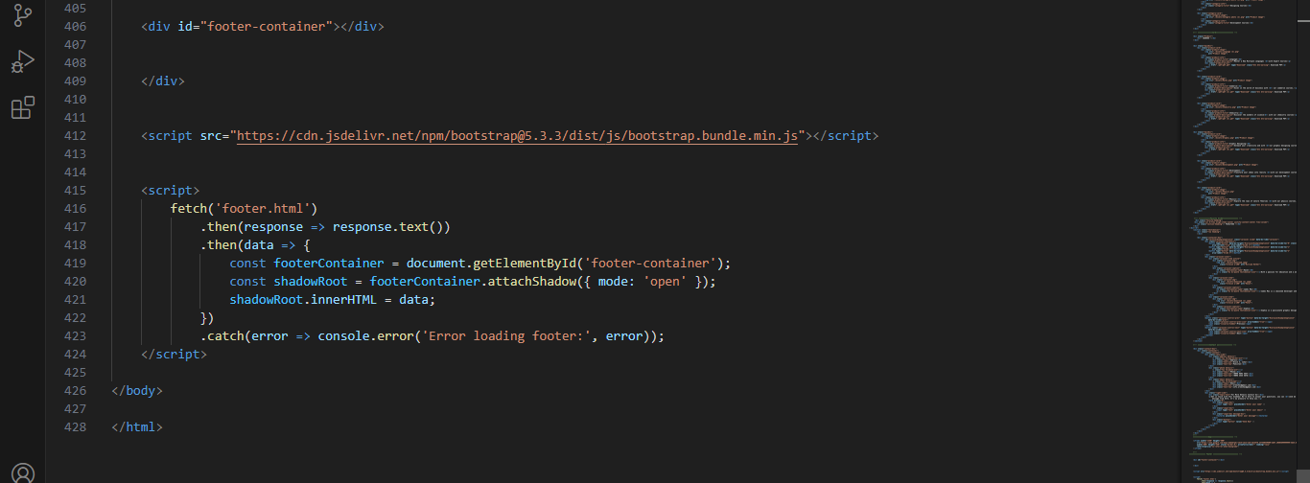

[ THE END ]

